Form 2346 Product Guide

# Form 2346 Description

The Medical Device Ordering Tool (MDOT) allows Veterans to order eligible hearing aid batteries and accessories through VA.gov. This online form is equivalent to VA Form 2346.

# Form 2346 Walkthrough

Note: All user data displayed in these screenshots is fake test user data.

## Happy Path

### Public Website Page

Navigate to [VA.gov](https://www.va.gov/) and follow the steps below:

1. Click “VA Benefits and Health Care”

2. Click “Health care” from the dropdown

3. Click the “Order hearing aid batteries and accessories” link under the “Manage your health” column.

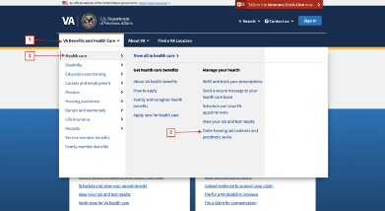

Once you click the link, you will arrive at the first page. The page will vary slightly depending on if you are signed in or not. Below are snapshots of the key differences between the experiences.

If you are signed in:

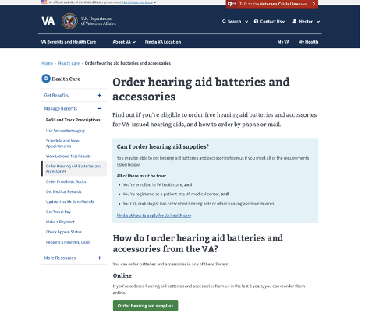

If you are not signed in:

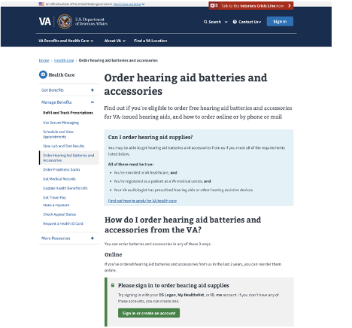

You must sign in to order hearing aid supplies online. Once you click the sign in button, you will see a modal prompting you to sign in. You may use any of the sign-in options on this modal to continue to the form.

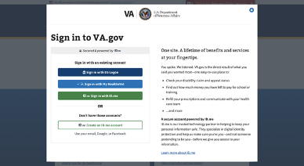

### Introduction Page

Once you are signed in, you will be taken to the introduction page. This page gives you an overview of the ordering process.

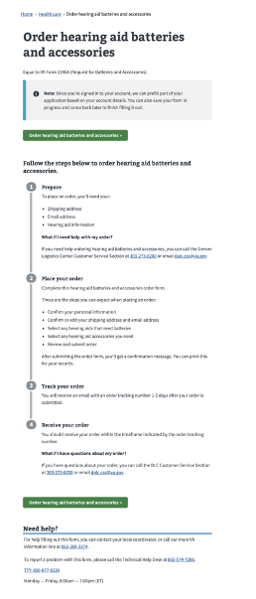

Click on either “Order hearing aid batteries and accessories” button to continue.

### Veteran information – Personal Details Page

On this page, you confirm your personal information such as your name and social security number. The page also provides a note on how to update that information if it’s incorrect.

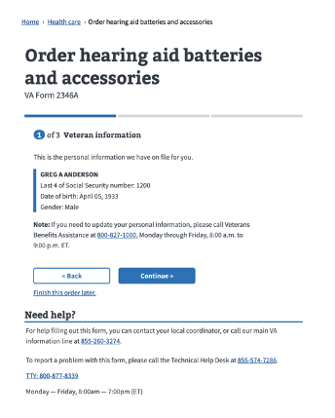

### Veteran information- Address Page

This page displays your addresses that are on file and asks which address you would like your supplies to be shipped to. The permanent address is selected by default. If you would like an email confirmation, you can enter and confirm your email address in the fields below.

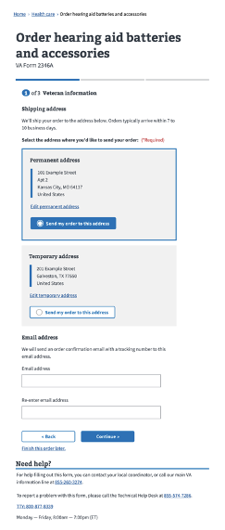

### Batteries Order Page

This page allows you to indicate which hearing aid devices that you may need batteries for. There is also content that explains what to do if you don’t see your hearing aid on the list.

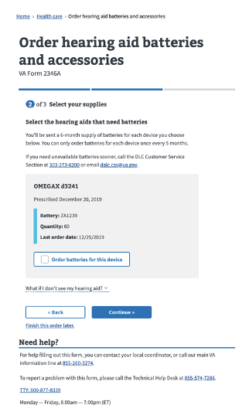

### Accessories Order Page

This page allows you to select any hearing aid accessories that you may want to order. There is also content that explains what to do if you don’t see the accessories that you need.

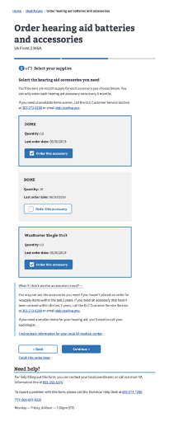

### Review Page

This page has two expandable sections that display all of the information you have entered into the form. You may edit your information or selected supplies on this page before submitting your order.

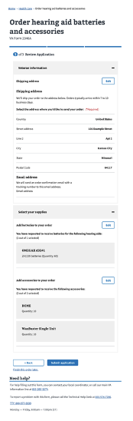

### Confirmation Page

This page is shown when the order submission is successful. It displays key information such as the address the supplies will be shipped to, the date of the order that was placed, and a confirmation number. It also provides insight on how long until the order arrives and if you have questions about your order.

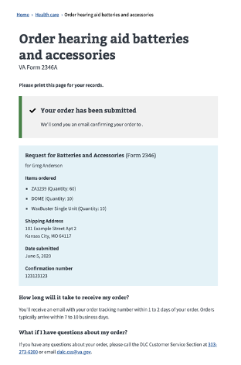

## Common Edge Cases

### Veteran information- Address Page

If you do not have a temporary address on file, the button for the permanent address card will not display a radio button. The temporary address card will inform you that you can add a temporary address.

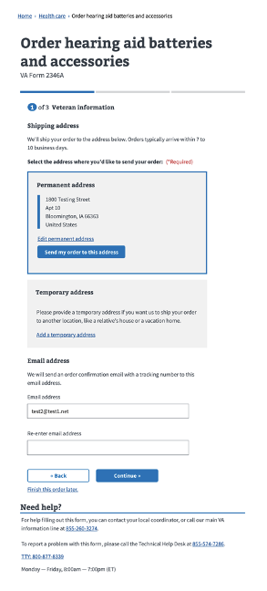

### Batteries Order Page

If you are ineligible to order batteries because you have ordered them within the past 5 months or your devices don’t require batteries, you will see an alert on the battery page. In place of selection buttons, all devices on the page will have a message explaining that the item is ineligible for reorder.

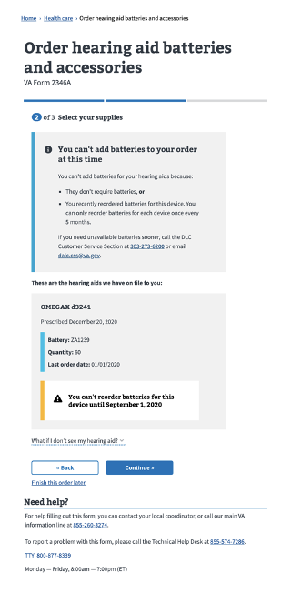

If you have not ordered batteries in the last 2 years, you will see the following alert:

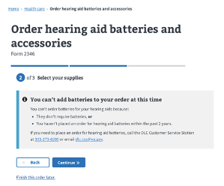

You may still order accessories on the following page of the form after hitting the ‘Continue’ button.

### Accessories Order Page

If you haven’t ordered accessories within the past 2 years, you will see an alert and no accessories will be shown.

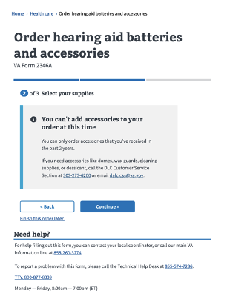

If you have ordered accessories in the last 5 months, you will see an alert that tells you the earliest day you can reorder accessories:

